ASTHMA POLICY

Kindoo/ Our ARK Pty Ltd

This policy was written in consultation with The Asthma Foundation of Victoria. The Foundation’s Asthma & the Child in Care Model Policy has been incorporated into this policy by Kindergarten Parents Victoria (KPV). For more detailed information, visit The Asthma Foundation of Victoria’s website: www.asthma.org.au

PURPOSE | This policy will outline the procedures to:  - ensure educators, staff and parents/guardians are aware of their obligations and the best practice management of asthma at Kindoo!  - ensure that all necessary information for the effective management of children with asthma enrolled at Kindoo! is collected and recorded so that these children receive appropriate attention when required  - respond to the needs of children who have not been diagnosed with asthma and who experience breathing difficulties (suspected asthma attack) at the service.
REQUIREMENT | Mandatory – Quality Area 2
REVIEW DATE | This policy shall be reviewed in April 2018.

POLICY STATEMENT

1. VALUES
Kindoo! is committed to:
- providing a safe and healthy environment for all children enrolled at the service
- providing an environment in which all children with asthma can participate to their full potential providing a clear set of guidelines and procedures to be followed with regard to the management of asthma
- educating and raising awareness about asthma among educators, staff, parents/guardians and any other person(s) dealing with children enrolled at the service.

2. SCOPE
This policy applies to the Approved Provider, Nominated Supervisor, Person in Day to Day Charge (PIDTDC), educators, staff, students on placement, volunteers, parents/guardians, children and others attending the programs and activities of Kindoo!.
Asthma management should be viewed as a shared responsibility. While Kindoo! recognises its duty of care towards children with asthma during their time at the service, the responsibility for ongoing asthma management rests with the child’s family and medical practitioner.

3. BACKGROUND AND LEGISLATION

Background
Asthma is a chronic, treatable health condition that affects approximately one in 10 Australian children and is the most common reason for childhood admission to hospital. With good asthma management, people with asthma need not restrict their daily activities. Community education assists in generating a better understanding of asthma within the community and minimising its impact.
Symptoms of asthma include wheezing, coughing (particularly at night), chest tightness, difficulty in breathing and shortness of breath, and symptoms may vary between children. It is generally accepted that children under six years of age do not have the skills and ability to recognise and manage their own asthma without adult assistance. With this in mind, a service must recognise the need to educate staff and parents/guardians about asthma and promote responsible asthma management strategies.
Legislation that governs the operation of approved children’s services is based on the health, safety and welfare of children, and requires that children are protected from hazards and harm. The Approved Provider will ensure that there is at least one educator on duty at all times who has current approved emergency asthma management training in accordance with the Education and Care Services National Regulations 2011 (Regulation 136(c)). As a demonstration of duty of care and best practice, KPV recommends all educators have current approved emergency asthma management training (refer to Definitions).

Legislation and standards
Relevant legislation and standards include but are not limited to:
Education and Care Services National Law Act 2010: Sections 167, 169, 174
Education and Care Services National Regulations 2011: Regulations 90, 92, 93, 94, 95, 96, 136, 137
Health Records Act 2001 (Vic)
National Quality Standard, Quality Area 2: Children’s Health and Safety
Standard 2.1: Each child’s health is promoted
Element 2.1.1: Each child’s health needs are supported
Standard 2.3: Each child is protected
Element 2.3.3: Plans to effectively manage incidents and emergencies are developed in consultation with relevant authorities, practised and implemented
Information Privacy Act 2000 (Vic)
Privacy Act 1988 (Cth)
Public Health and Wellbeing Act 2008 (Vic)
Public Health and Wellbeing Regulations 2009 (Vic)

4. DEFINITIONS
The terms defined in this section relate specifically to this policy.

Approved Emergency Asthma Management (EAM) training: Training that is approved by the
National Authority in accordance with Division 7 of the National Regulations, and is listed on the ACECQA website: http://www.acecqa.gov.au. EAM training provides knowledge about the underlying causes of asthma, asthma triggers, and the recognition and treatment of an asthma attack.
Asthma Child and Adolescent Program (ACAP): A Commonwealth Government funded, one-hour asthma training program available free of charge to all preschool staff (four-year-old funded program). This training covers asthma management and first aid in an emergency. Asthma Australia
recommends that all education staff working on site (teaching and non-teaching) attend an ACAP session. The program also provides resources to parents/guardians and carers of children with asthma.
Asthma Friendly Children’s Services Program: A program developed by The Asthma Foundation of Victoria to provide a safer environment for children in kindergarten, childcare, family day care and out-of-school hours care. This program also gives staff the confidence and skills to care for a child with asthma and gives parents/guardians peace of mind. To be recognised as an Asthma Friendly Children’s Service, services must address and fulfill five essential criteria, which will be assessed by The Asthma Foundation of Victoria. Upon accreditation, the service will receive a certificate and window sticker. This accreditation is valid for three years.
Asthma Action Plan: A record of information of an individual child’s asthma and its management, including contact details, what to do when the child’s asthma worsens and the treatment to be administered in an emergency. Asthma Action Plan templates can be downloaded from The Asthma Foundation of Victoria’s website: www.asthma.org.au. A sample plan specifically for use in children’s services is provided in this policy as Attachment 2.
Asthma emergency: The onset of unstable or deteriorating asthma symptoms requiring immediate treatment with reliever medication.
Asthma first aid kit: Kits should contain:

- reliever medication
- 2 small volume spacer devices
- 2 compatible children’s face masks
- record form
- asthma first aid instruction card.
The Asthma Foundation of Victoria recommends that spacers and face masks are for single-use only. It is essential to have at least two spacers and two face masks in each first aid kit, and these should be replaced once used.
Asthma triggers: Things that may induce asthma symptoms, for example, pollens, colds/viruses, dust mites, smoke and exercise. Asthma triggers will vary from child to child.
Duty of care: A common law concept that refers to the responsibilities of organisations to provide people with an adequate level of protection against harm and all reasonable foreseeable risk of injury.
Medication record: Contains details for each child to whom medication is to be administered by the service. This includes the child’s name, signed authorisation to administer medication and a record of the medication administered, including time, date, dosage, manner of administration, name and signature of person administering the medication and of the person checking the medication, if required (Regulation 92). A sample medication record is available on the ACECQA website.
Metered dose inhaler (puffer): A common device used to administer reliever medication.
Puffer: The common name for a metered dose inhaler.
Reliever medication: This comes in a blue/grey metered dose inhaler containing salbutamol, a chemical used to relax the muscles around the airways to relieve asthma symptoms. This medication is always used in an asthma emergency. Reliever medication is commonly sold by pharmacies as Airomir, Asmol, Epaq or Ventolin.
Spacer device: A plastic device used to increase the efficiency of delivery of reliever medication from a puffer. It should always be used in conjunction with a puffer device and may be used in conjunction with a face mask.
Staff record: Must be kept by the service and include details of the Nominated Supervisors, the educational leader, other staff members, volunteers and the Responsible Person. The record must include information about qualifications, training and details of the Working with Children Check (Regulations 146–149). A sample staff record is available on the ACECQA website: https://www.acecqa.gov.au/resources/applications/sample-forms-and-templates

5. SOURCES AND RELATED POLICIES

Sources
Asthma Australia: www.asthmaaustralia.org.au
The Asthma Foundation of Victoria: www.asthma.org.au or phone (03) 9326 7088 or 1800 645 130 (toll free)
Australian Children’s Education and Care Quality Authority (ACECQA): www.acecqa.gov.au
Guide to the Education and Care Services National Law and the Education and Care Services National Regulations 2011, ACECQA

Service policies
Administration of Medication Policy
Anaphylaxis Policy
Dealing with Medical Conditions Policy
Emergency and Evacuation Policy
Excursions and Service Events Policy
Incident, Injury, Trauma and Illness Policy
Privacy and Confidentiality Policy
Staffing Policy

PROCEDURES
The Approved Provider is responsible for:
- providing the Nominated Supervisor and all staff with a copy of the service’s Asthma Policy, and ensuring that they are aware of asthma management strategies (refer to Attachment 1) upon employment at the service
- providing approved Emergency Asthma Management (EAM) training (refer to Definitions) to staff as required under the National Regulations
- ensuring at least one staff member with current approved Emergency Asthma Management (EAM) training (refer to Definitions) is on duty at all times
- ensuring the details of approved Emergency Asthma Management (EAM) training (refer to
- Definitions) are included on the staff record (refer to Definitions)
- providing parents/guardians with a copy of the service’s Asthma Policy upon enrolment of their child (Regulation 91)
- identifying children with asthma during the enrolment process and informing staff providing parents/guardians with an Asthma Action Plan (refer to Attachment 2) to be completed in consultation with, and signed by, a medical practitioner
- developing a Risk Minimisation Plan (refer to Attachment 4) for every child with asthma, in consultation with parents/guardians

- ensuring that all children with asthma have an Asthma Action Plan and Risk Minimisation Plan filed with their enrolment record
- ensuring a medication record is kept for each child to whom medication is to be administered by the service (Regulation 92)
- ensuring parents/guardians of all children with asthma provide reliever medication and a spacer
(including a child’s face mask, if required) at all times their child is attending the service
- implementing an asthma first aid procedure (refer to Attachment 1) consistent with current national recommendations
- ensuring that all staff are aware of the asthma first aid procedure
- ensuring adequate provision and maintenance of asthma first aid kits (refer to Definitions)
- ensuring the expiry date of reliever medication is checked regularly and replaced when required,
- ensuring that spacers and face masks are disposed of after every use
- facilitating communication between management, educators, staff and parents/guardians regarding the service’s Asthma Policy and strategies
- identifying and minimising asthma triggers (refer to Definitions) for children attending the service, where possible
- ensuring that children with asthma are not discriminated against in any way
- ensuring that children with asthma can participate in all activities safely and to their full potential
- immediately communicating any concerns with parents/guardians regarding the management of children with asthma at the service
- ensuring that the service meets the requirements to be recognised as an Asthma Friendly Children’s Service (refer to Definitions) with The Asthma Foundation of Victoria
- displaying Asthma Australia’s Asthma First Aid poster (refer to Sources and Attachment 3) in key locations at the service
- ensuring that medication is administered in accordance with the Administration of Medication Policy
- ensuring that when medication has been administered to a child in an asthma emergency without authorisation from the parent/guardian or authorised nominee, the parent/guardian of the child and emergency services are notified as soon as is practicable (Regulation 94).
The Nominated Supervisor is responsible for:
- ensuring that all educators’ approved first aid qualifications, anaphylaxis management training and Emergency Asthma Management (EAM) training are current, meet the requirements of the National Law (Section 169(4)) and National Regulations (Regulation 137), and are approved by ACECQA
- ensuring that medication is administered in accordance with the Administration of Medication Policy
- ensuring that when medication has been administered to a child in an asthma emergency without authorisation from the parent/guardian or authorised nominee, the parent/guardian of the child and emergency services are notified as soon as is practicable (Regulation 94)
- ensuring an asthma first aid kit (refer to Definitions) is taken on all excursions and other offsite activities (refer to Excursions and Service Events Policy)

- compiling a list of children with asthma and placing it in a secure, but readily accessible, location known to all staff. This should include the Asthma Action Plan for each child
- ensuring that induction procedures for casual and relief staff include information about children attending the service who have been diagnosed with asthma, and the location of their medication and action plans
- organising asthma management information sessions for parents/guardians of children enrolled at the service, where appropriate
- ensuring programmed activities and experiences take into consideration the individual needs of all children, including any children with asthma.
PIDTDC/s and other educators are responsible for:
- ensuring that they are aware of the service’s Asthma Policy and asthma first aid procedure (refer to Attachment 1)
- ensuring that they can identify children displaying the symptoms of an asthma attack and locate their personal medication, Asthma Action Plans and the asthma first aid kit
- maintaining current approved Emergency Asthma Management (EAM) (refer to Definitions) qualifications identifying and, where possible, minimising asthma triggers (refer to Definitions) as outlined in the child’s Asthma Action Plan
- taking the asthma first aid kit, children’s personal asthma medication and Asthma Action Plans on excursions or other offsite events
- administering prescribed asthma medication in accordance with the child’s Asthma Action Plan and the Administration of Medication Policy of the service
- developing a Risk Minimisation Plan (refer to Attachment 4) for every child with asthma in consultation with parents/guardians
- discussing with parents/guardians the requirements for completing the enrolment form and medication record for their child
- consulting with the parents/guardians of children with asthma in relation to the health and safety of their child, and the supervised management of the child’s asthma
- communicating any concerns to parents/guardians if a child’s asthma is limiting his/her ability to participate fully in all activities
- ensuring that children with asthma are not discriminated against in any way
- ensuring that children with asthma can participate in all activities safely and to their full potential.

Parents/guardians are responsible for:
- reading the service’s Asthma Policy
- informing staff, either on enrolment or on initial diagnosis, that their child has asthma
- providing a copy of their child’s Asthma Action Plan to the service and ensuring it has been
- prepared in consultation with, and signed by, a medical practitioner. The Asthma Action Plan should be reviewed and updated at least annually
- ensuring all details on their child’s enrolment form and medication record (refer to Definitions) are completed prior to commencement at the service
- working with staff to develop a Risk Minimisation Plan (refer to Attachment 4) for their child providing an adequate supply of appropriate asthma medication and equipment for their child at all times
- notifying staff, in writing, of any changes to the information on the Asthma Action Plan, enrolment form or medication record
- communicating regularly with educators/staff in relation to the ongoing health and wellbeing of their child, and the management of their child’s asthma
- encouraging their child to learn about their asthma, and to communicate with service staff if they are unwell or experiencing asthma symptoms.
Volunteers and students, while at the service, are responsible for following this policy and its procedures.

EVALUATION
In order to assess whether the values and purposes of the policy have been achieved, the Approved Provider will:
regularly seek feedback from everyone affected by the policy regarding its effectiveness monitor the implementation, compliance, complaints and incidents in relation to this policy
keep the policy up to date with current legislation, research, policy and best practice revise the policy and procedures as part of the service’s policy review cycle, or as required
- notify parents/guardians at least 14 days before making any changes to this policy or its
procedures.

ATTACHMENTS
Attachment 1: Asthma First Aid Procedure
Attachment 2: Sample Asthma Action Plan
Attachment 3: Asthma First Aid poster
Attachment 4: Asthma Risk Minimisation Plan

ATTACHMENT 1 Asthma First Aid Procedure
This Asthma First Aid Procedure has been reproduced from The Asthma Foundation of Victoria’s Asthma & the Child in Care Model Policy, Version 6.4, January 2012.

ASTHMA FIRST AID PROCEDURE
Follow the written first aid instructions on the child’s Asthma Action Plan, if available and signed by a medical practitioner. If no specific and signed instructions are available, the instructions are unclear, or the child does not have an Asthma Action Plan, begin the first aid procedure outlined below.
Reliever medication is safe to administer to children, even if they do not have asthma, however if there is no Asthma Action Plan you must also call emergency assistance to attend (000) and notify the parent/carer of the child as soon as possible.

Call emergency assistance immediately (Dial 000)
If the person is not breathing
If the person’s asthma suddenly becomes worse, or is not improving
If the person is having an asthma attack and a blue reliever puffer is not available If you are not sure it is asthma

Step 1. Sit the person upright
Be calm and reassuring
Do not leave them alone
(Send someone else to get the asthma first aid kit)
(Sitting the child in an upright position will make it easier for them to breathe)

Step 2. Give 4 puffs of blue reliever puffer medication
Use a spacer if there is one
Shake the puffer
Put 1 puff into the spacer
Take 4 breaths from spacer
Repeat until 4 puffs have been taken
Remember: Shake, 1 puff, 4 breaths
(This medication is safe to administer and may be lifesaving)
Step 3. Wait 4 minutes
If there is no improvement, give 4 more puffs as above

Step 4. If there is still no improvement call emergency assistance (000)
Say ambulance and that someone is having an asthma attack
Keep giving 4 puffs every 4 minutes until emergency assistance arrives
(If calling Triple Zero (000) doesn’t work on your mobile phone, try 112)

ATTACHMENT 2 Sample Asthma Action Plan
This sample Asthma Action Plan is available for download from The Asthma Foundation of Victoria’s website.
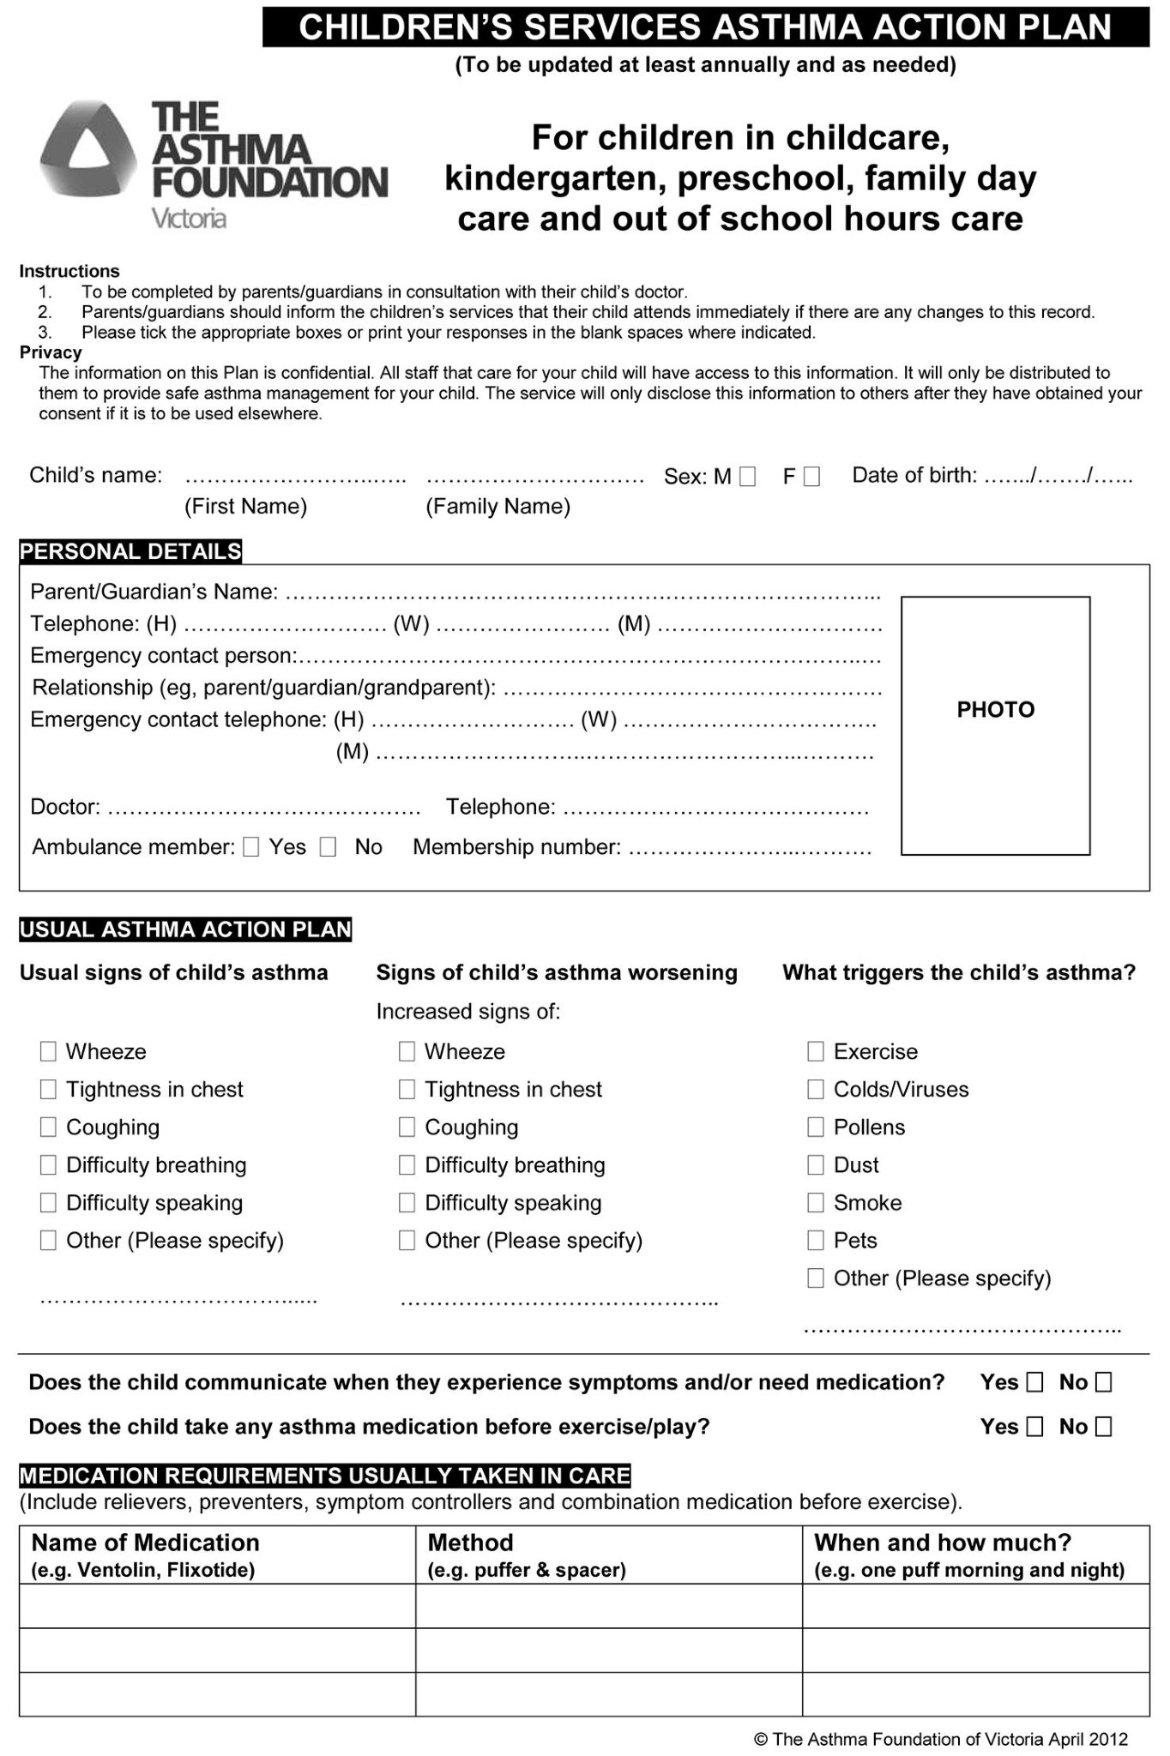
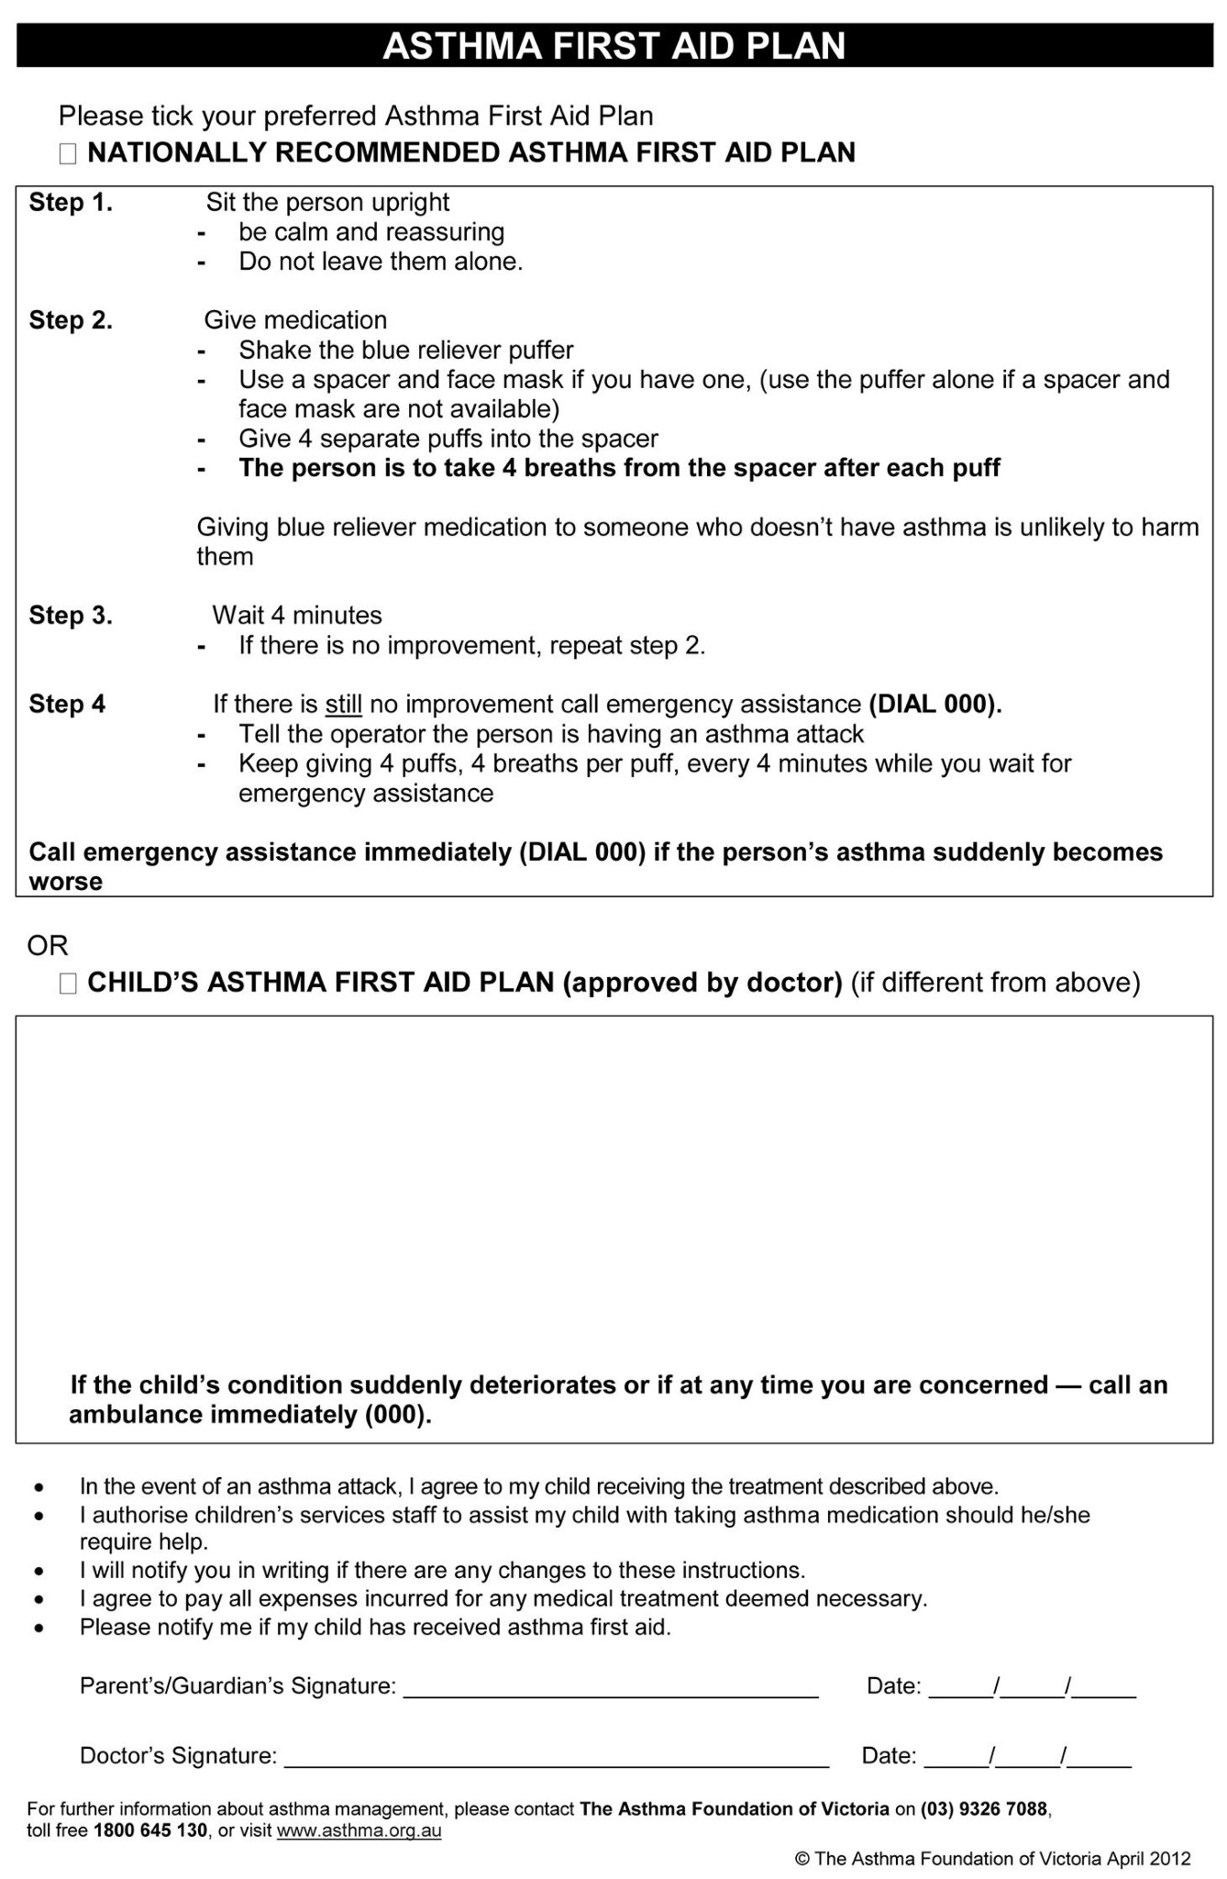

ATTACHMENT 3 Asthma First Aid poster
This poster is available for download from The Asthma Foundation of Victoria’s website.
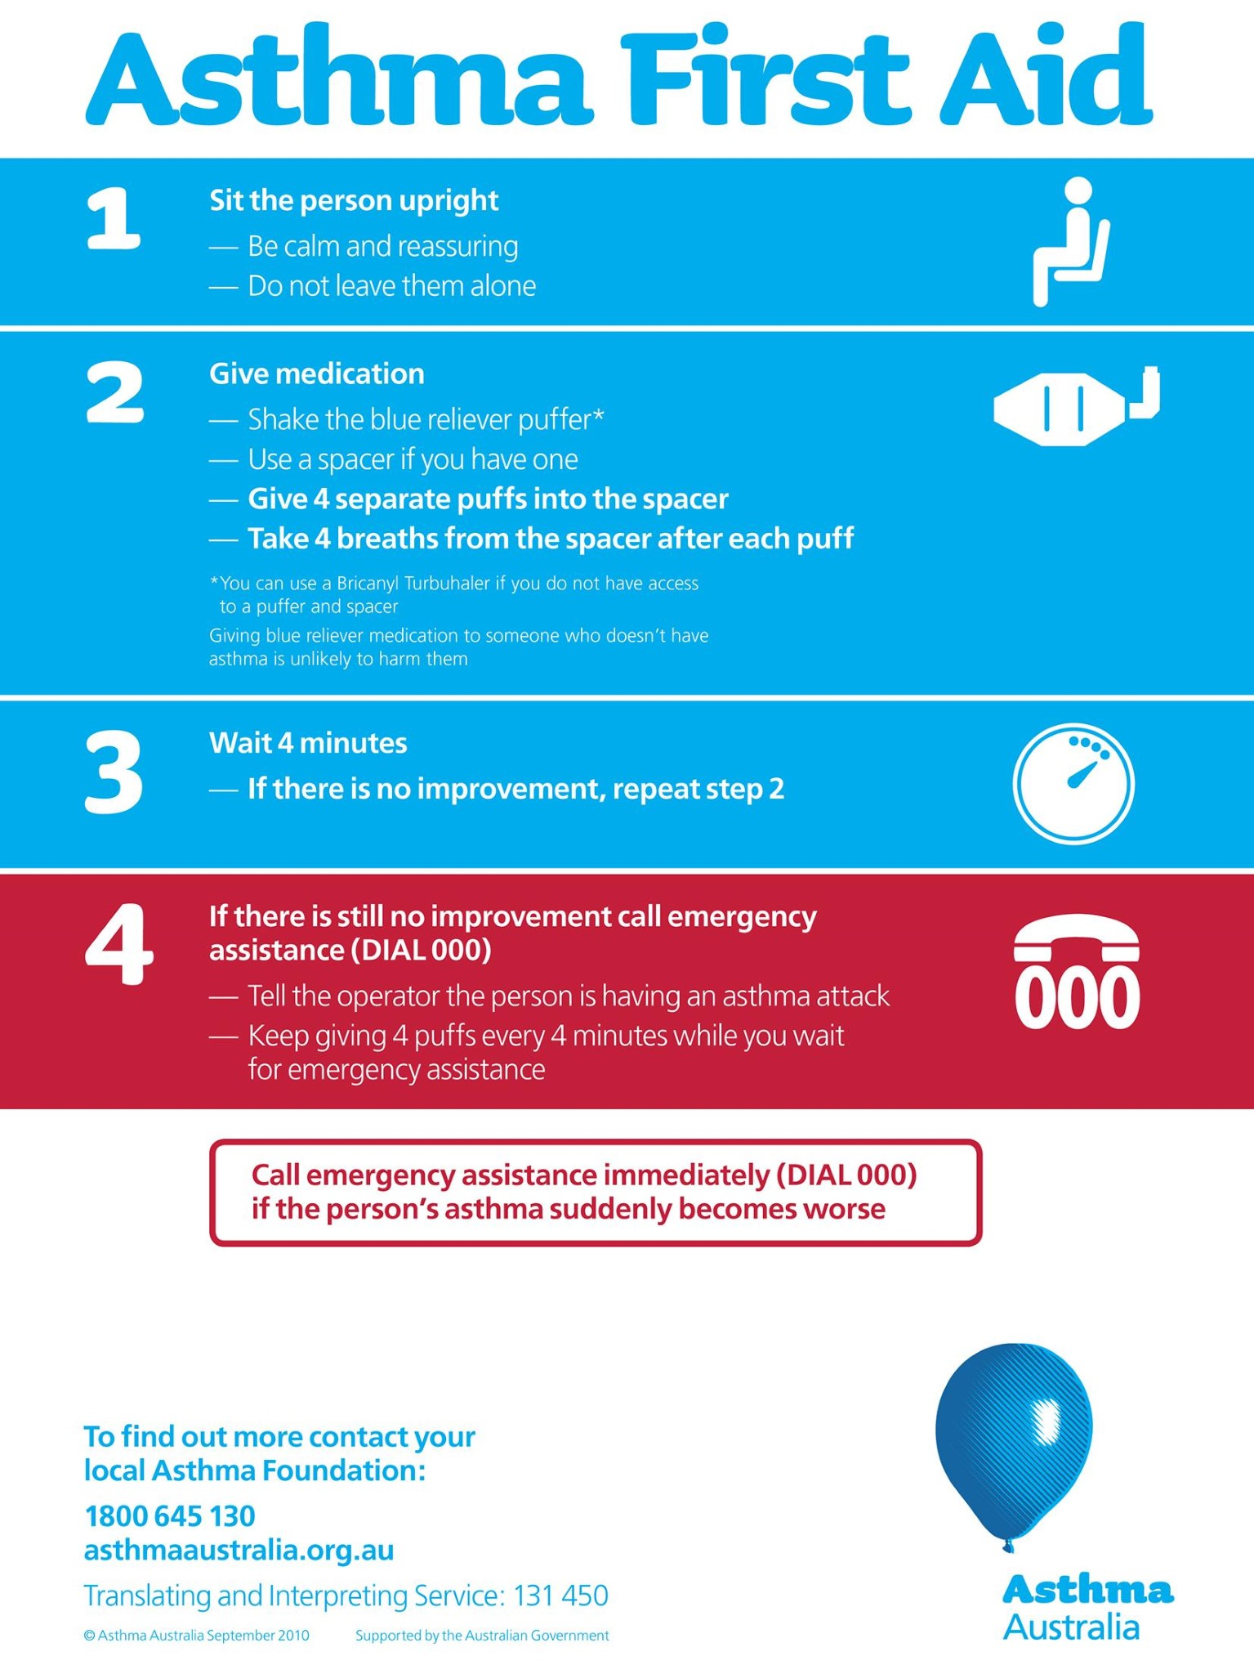

ATTACHMENT 4 Asthma Risk Minimisation Plan
